**URL:** <https://www.legifrance.gouv.fr/>

In the Advanced Search (*Recherche avancée*), start by selecting the type of fund from the dropdown menu (see label (1) below), which includes options like Consolidated Texts (*Textes consolidés*), Official Journal (*Journal officiel*), Circulars and Instructions (*Circulaires et instructions*), and Constitutional Jurisprudence (*Jurisprudence constitutionnelle*). Note that only one content type can be selected at a time. Next, choose 'In the titles' (*Dans les titres*) as the next criterion (labeled as (2) below).

To refine the search, select the following type of text under its corresponding type of fund as follows:

1. Consolidated Texts (*Textes consolidés*)

* Laws (*Lois*)
* Order (*Ordonnances*)
* Decrees (*Décrets*)
* Arrested (*Arrêtés*)
* Decree laws (*Décrets-loi*)

1. Official Journal (*Journal official*)

* Arrested (*Arrêtés*)
* Circular (*Circulaire*)
* Decree (*Décret*)
* Decree-law (*Décret-loi*)
* Law (*Loi*)
* CONSTITUTIONAL LAW (*LOI_CONSTIT*)

In the search text field (*Texte recherché*), use the keywords marked 'Yes' in the *France - keywords for site search.xlsx* file. It's worth noting that using French keywords returns more result than using the English equivalent. However, make sure to set the source language to French before entering the keywords.

In the results page, extract the following metadata as indicated below:

* Red – Title and the Source Link
* Green – Type of Regulation
* Blue – Date of Adoption
* Purple – Entry into Force Date

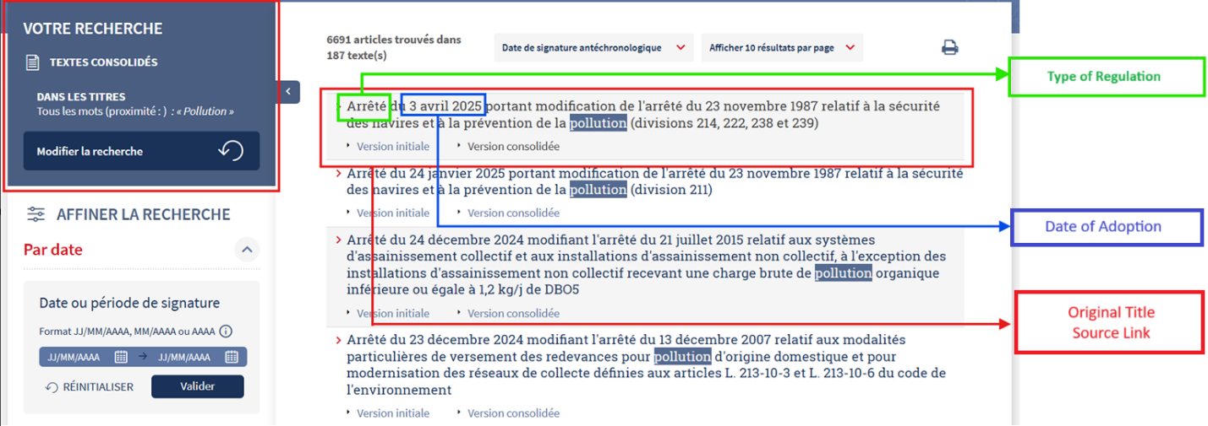

Note that the Entry into Force Date is not readily visible on the results page. To obtain it, you must open the specific legislation, where the date is typically indicated in the header beginning with 'JORF n°... of [date]'.

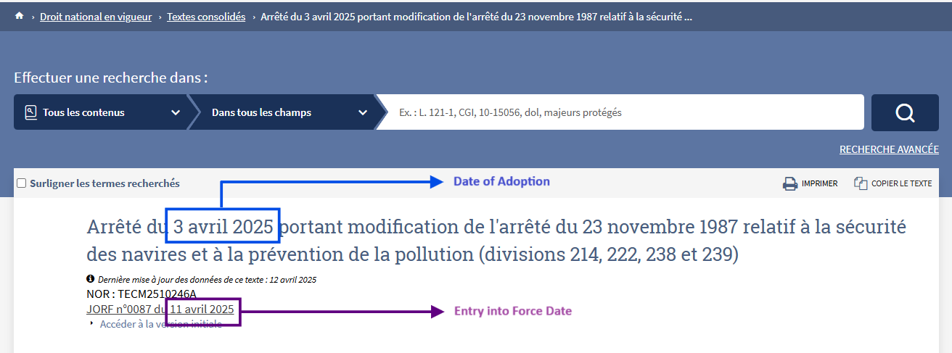

If this date is not visible, click 'Access the initial version' (Accéder à la version initiale) to be redirected to the Official Journal, where the publication date can be found.

